Assignment #4 Basic Data Viz by Joshua Troup

1. What are the products that are under performing?

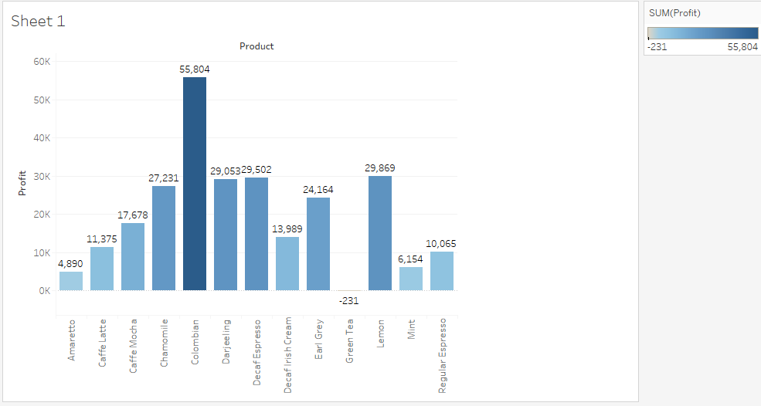

**The graph above displays the total profit for each product that is offered within the chain of coffee houses. The dark blue represents the greatest profit and the lighter sky blue represents a lower profit. Green tea is the only product showing a negative profit.**

1. What states show the most profitability?

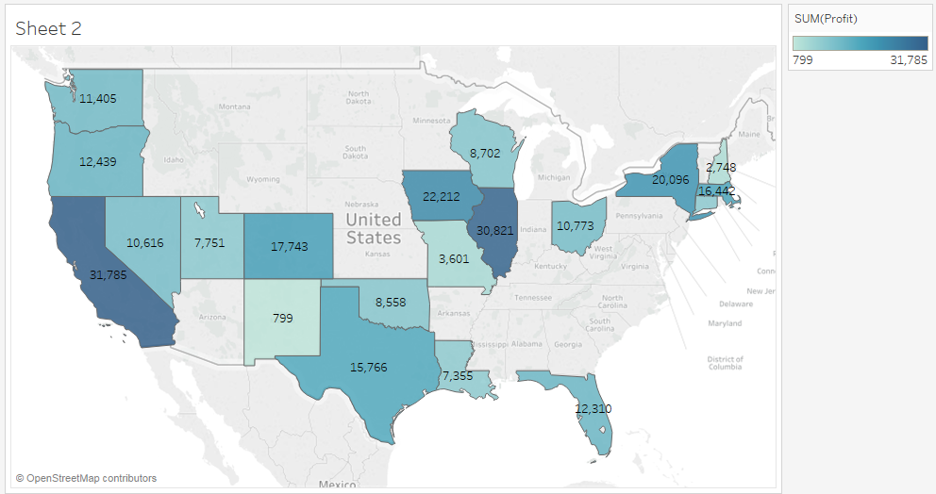

**The graph above shows the profits of the coffee houses by state. California and Illinois are the most profitable states shown in dark blue. New Mexico showing the least amount of profit with $799 in light blue. There seems to be no loss or negative profit based by states which tells us location does not create profitability issues.**

1. Profits and losses of products based on geographic location. (State)

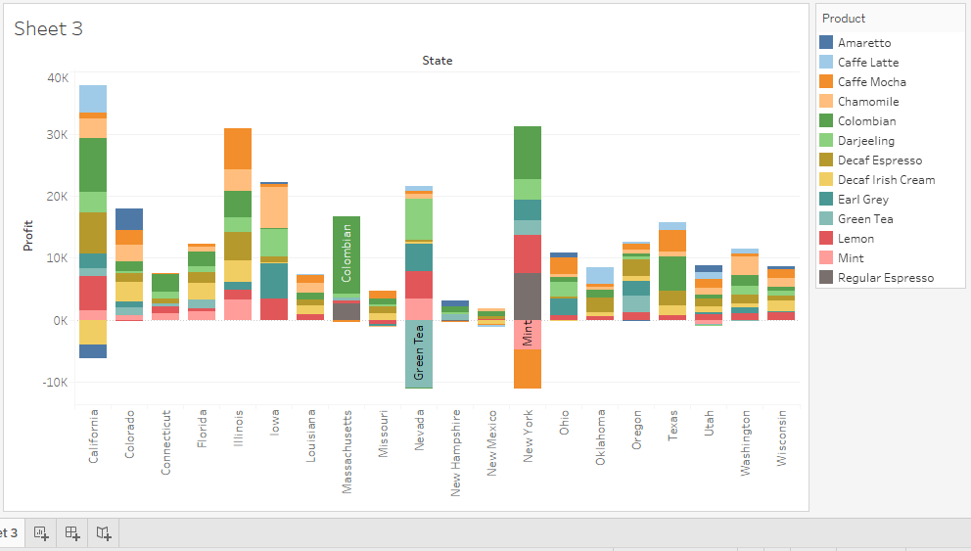

**The graph above displays the profitability of individual products in individual states. We can clearly see what product is doing well or not by using the color guide on the right side of the screen. California shows to have a negative profit on Decaf Irish Cream (-$3,891) and Amaretto (-$2,217). Nevada has a negative profit in Green Tea (-$10,980). New York has a negative profit in Mint (-$4,780) and Caffe Mocha (-$6,354).**

1. Is advertisement and marketing influencing the loss of profits?

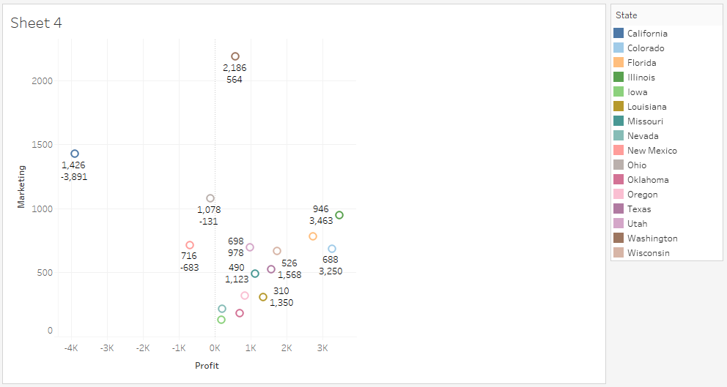

DECAF IRISH CREAM

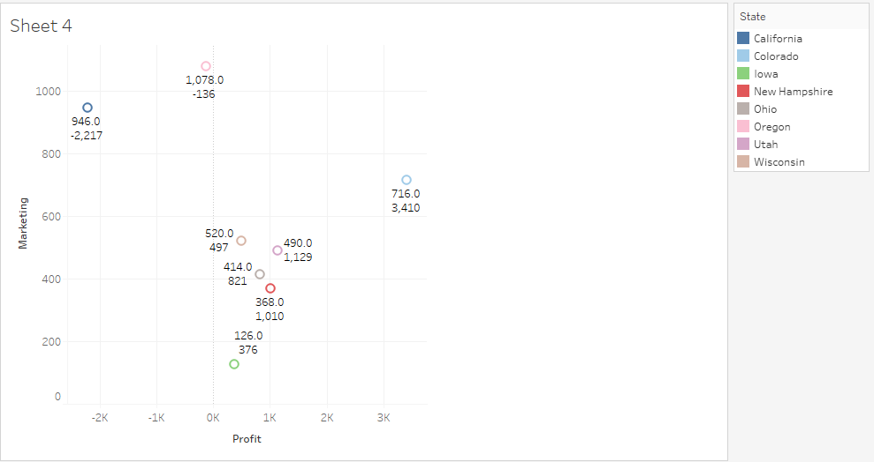

AMARETTO

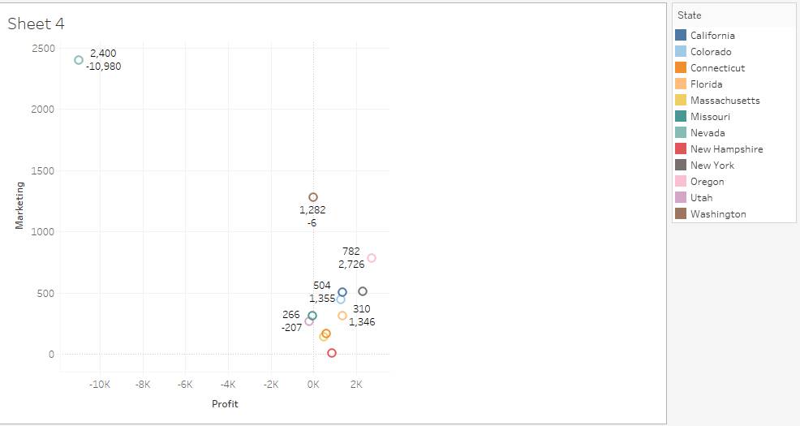

GREEN TEA

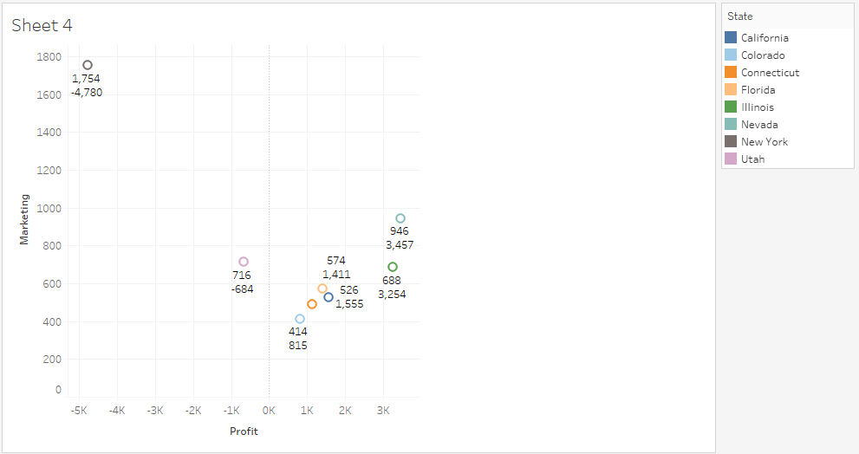

MINT

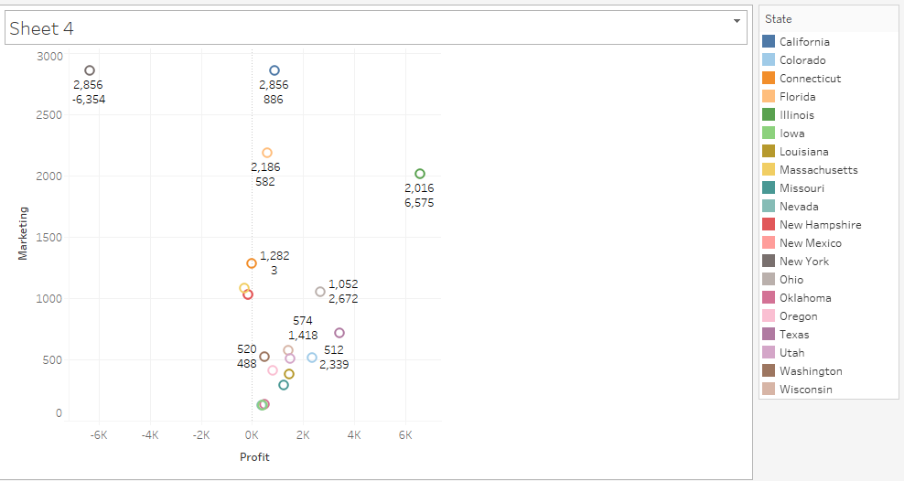

CAFÉ MOCHA

**The graphs above display the marketing on top and the profit on the bottom color coded by state. The negative outliers are on the left. The negative profits seem to have a correlation with the marketing. The more spent on marketing, the less profit is made. Promotional discounted prices I expect play a viable role in the decrease in profits.**

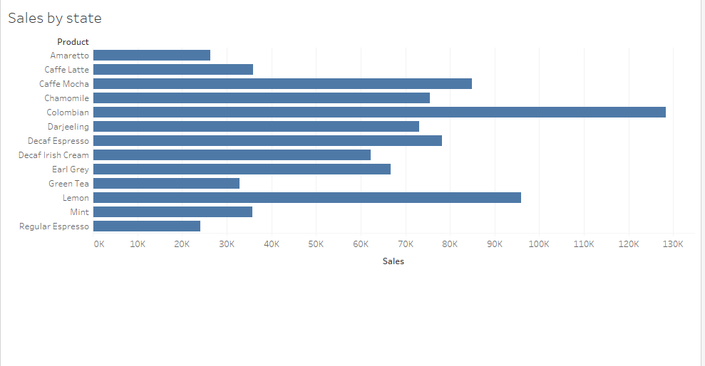

**The graph above displays sales by state. I wanted in investigate Green Tea a bit further to see if it was simply not a hot seller. The negative profit products are not as strong in sales as others however Regular Espresso is an exception. Regular Expresso was approx. $25K in sales (the lowest in sales) but produced a $10,065 profit. This is evidence that the negative profit items are being offered at discounted or promotional rates.**